Front End Engineering-II

Project Report Semester-IV (Batch-2022)

Movie-App



**Supervised By:**

Raveesh Samkaria

**Submitted By:**

Tanisha

Roll Number: -2210990892

Group - 13

## Department of Computer Science and Engineering Chitkara University Institute of Engineering & Technology,

**Chitkara University, Punjab**

FEE-II, 22CS0014

1

# Abstract

MovieSphere is a dynamic and immersive movie website crafted with HTML, Bootstrap, JavaScript, and CSS. It serves as a comprehensive platform for cinephiles and casual moviegoers alike, offering a seamless and captivating experience for exploring the vast world of cinema.

Upon entering MovieSphere, users are greeted with a visually stunning and user-friendly interface, designed to engage and captivate audiences from the moment they arrive. The website features a sleek and modern design, with intuitive navigation elements that make browsing a breeze.

One of the standout features is its extensive database of movies spanning various genres, languages, and eras. Users can search for their favorite films, discover hidden gems, and explore curated lists tailored to their preferences. The website also provides detailed information about each movie, including cast and crew details, synopsis, ratings, and reviews.

In addition to its robust catalog of movies, this website offers a range of interactive features to enhance the user experience. Users can create personalized watchlists, rate and review films, and engage in lively discussions with fellow movie enthusiasts. The website also provides recommendations based on user preferences, ensuring that every visit to Moviesphere is filled with exciting discoveries.

With its seamless integration of HTML, Bootstrap, JavaScript, and CSS, the website sets a new standard for movie websites, combining stunning design with powerful functionality to create an unparalleled cinematic experience. Whether you're a seasoned film buff or a casual moviegoer, Moviesphere invites you to embark on a journey through the captivating world of cinema.

FEE-II, 22CS0014

2

# Table of Contents

|  |  |  |
| --- | --- | --- |
| **Sr.no** | **Section** | **Page No.** |
| **1** | **Introduction** | 4 |
| **2** | **Problem Statement** | 5 |
| **3** | **Technical Details** | 6 |
| **5** | **File Structure** | 7 |
| **6** | **Result** | 8-22 |
| **7** | **References** | 23 |
|  |  |  |

FEE-II, 22CS0014

3

# Introduction

Moviesphere – a dynamic movie website designed to immerse users in the captivating world of cinema. Built using HTML, JavaScript, Bootstrap, and CSS, Moviesphere offers a seamless and visually stunning platform for discovering, exploring, and enjoying movies of all genres.

Key Features:

**Dynamic Poster Showcase:**

The homepage features an eye-catching display of movie posters that change dynamically, creating an engaging visual experience for visitors.

Leveraging JavaScript, each poster is accompanied by relevant movie details such as title, description, and runtime, providing users with a glimpse into the storyline and genre.

**Explore Upcoming Releases:**

Users can stay informed about the latest movie releases through our curated selection of upcoming films.

With smooth scrolling functionality, visitors can effortlessly preview what's on the horizon and plan their movie nights in advance.

**User-Friendly Interface:**

Designed with a user-centric approach, Moviesphere prioritizes ease of use and accessibility.

Leveraging Bootstrap's grid system and CSS for styling, the website offers a cohesive and visually appealing layout across various screen sizes and devices.

FEE-II, 22CS0014

4

# Problem Statement

In today's fast-paced world, movie enthusiasts often struggle to find a reliable and engaging platform to discover, explore, and enjoy their favorite films. Existing movie websites may lack dynamic features, making it challenging for users to stay updated on the latest releases and trends in the cinematic world. Additionally, many platforms fail to provide an intuitive and visually appealing interface, leading to a less-than-optimal user experience.

To address these challenges, our goal is to create "Moviesphere" – a dynamic movie website that offers a seamless and immersive experience for users. This website will leverage HTML, JavaScript, Bootstrap, and CSS to provide a visually stunning platform where users can effortlessly discover new movies, watch trailers, and add films to their watchlist. By combining innovative features such as a dynamic poster showcase, curated lists of upcoming releases, and a trending section, it aims to revolutionize the way users engage with cinema online. Through this, we aim to solve the following key challenges:

Lack of Dynamic Content: Existing movie websites often lack dynamic features, resulting in static and outdated content. The website will address this by dynamically showcasing movie posters and accompanying details, keeping users engaged with fresh content.

Difficulty in Discovering New Movies: Users struggle to discover new movies and stay informed about upcoming releases. It will provide curated lists of upcoming releases and trending movies, making it easy for users to explore new titles and plan their movie nights.

Suboptimal User Experience: Many movie websites offer a cluttered or unintuitive interface, leading to a subpar user experience. It will prioritize user-friendly design principles, ensuring a seamless and enjoyable browsing experience for all users.

By tackling these challenges, it aims to become the go-to destination for movie enthusiasts seeking a dynamic, engaging, and user-friendly platform to explore the world of cinema.

FEE-II, 22CS0014

5

# Technical Details

**HTML (Hypertext Markup Language):**

Used for structuring the content of the website, including headers, paragraphs, lists, and other elements.

**CSS (Cascading Style Sheets):**

Responsible for styling the HTML elements, including layout, colors, fonts, and overall visual presentation.

Utilized to create responsive designs that adapt to various screen sizes and devices.

**Bootstrap:**

Employed for front-end development to leverage its grid system, components, and utilities for building responsive and mobile-first websites.

Streamlines the development process by providing pre-designed UI components and CSS classes.

**JavaScript:**

Utilized to add interactivity and dynamic behavior to the website.

Powers features such as dynamic poster showcase, smooth scrolling, trailer playback, and watchlist management.

**External APIs:**

**Movie Database API (e.g., The MovieDB API):**

Optionally integrated to fetch real-time movie data, including details, ratings, and trailers.

Provides comprehensive information about movies, enhancing the website's content and user experience.

By leveraging these frontend and backend technologies, along with proper data management and deployment strategies, the Moviesphere website can deliver a dynamic, engaging, and user-friendly experience to movie enthusiasts worldwide.

FEE-II, 22CS0014

6

# File Structure: -

* + **index.html**: outlines the structure and organization of the HTML document. It includes sections for the navbar, main content, upcoming movies, featured video, and trending movies
  + **index.css**: This CSS file contains custom styles for the Moviesphere website. It includes styles for the navbar, posters, buttons, cards, scroll arrows, and responsive design for smaller screens. These styles enhance the visual appeal and user experience of the website.
  + **index.js**: This JavaScript file contains the functionality for the website. It includes a poster carousel that cycles through movie posters with corresponding titles, descriptions, and release times. Additionally, it enables scrolling functionality for the galleries of upcoming releases and trending titles.
  + **assets folder**: This directory serves as the repository for all image assets utilized throughout the website. From logos to background images, each visual element is carefully curated to enrich the design and enhance the presentation of content. By organizing images methodically within this folder, accessibility and clarity are maintained, ensuring seamless integration into the website's layout.
  + **PSD file**: This PSD (Photoshop Document) file encapsulates the initial design mockup crafted using Adobe Photoshop. While not directly integrated into the website's development process, it serves as a guiding beacon for design elements, layout, and visual styling, facilitating consistency and fidelity between the envisioned design and the final product.

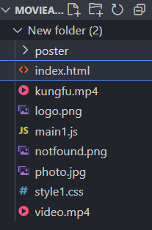

FEE-II, 22CS0014

7

# Result : HTML CODE

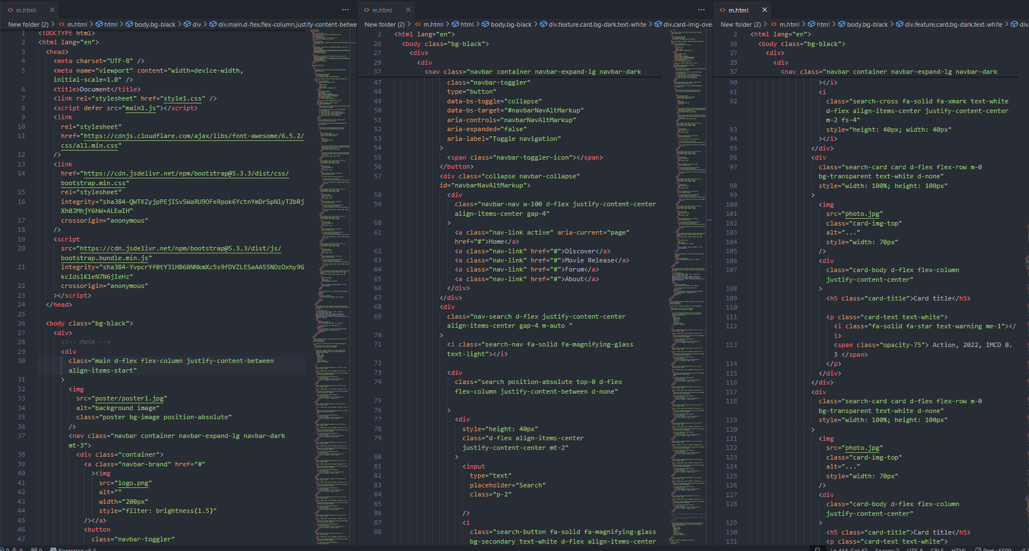

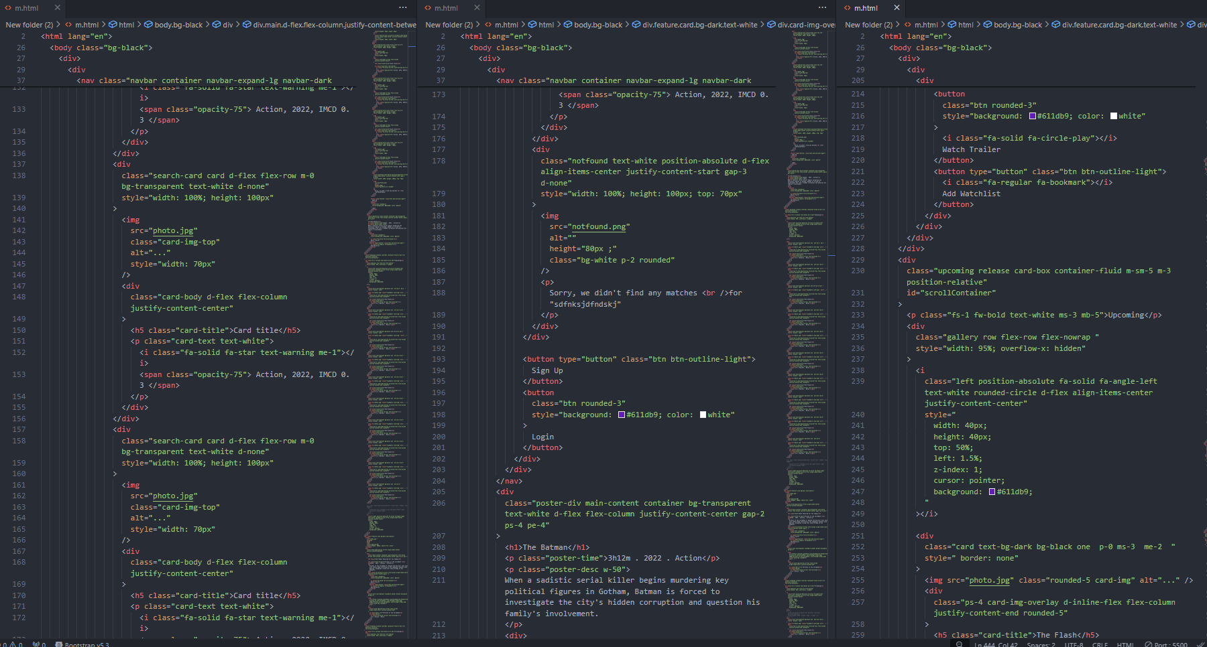

FEE-II, 22CS0014

8

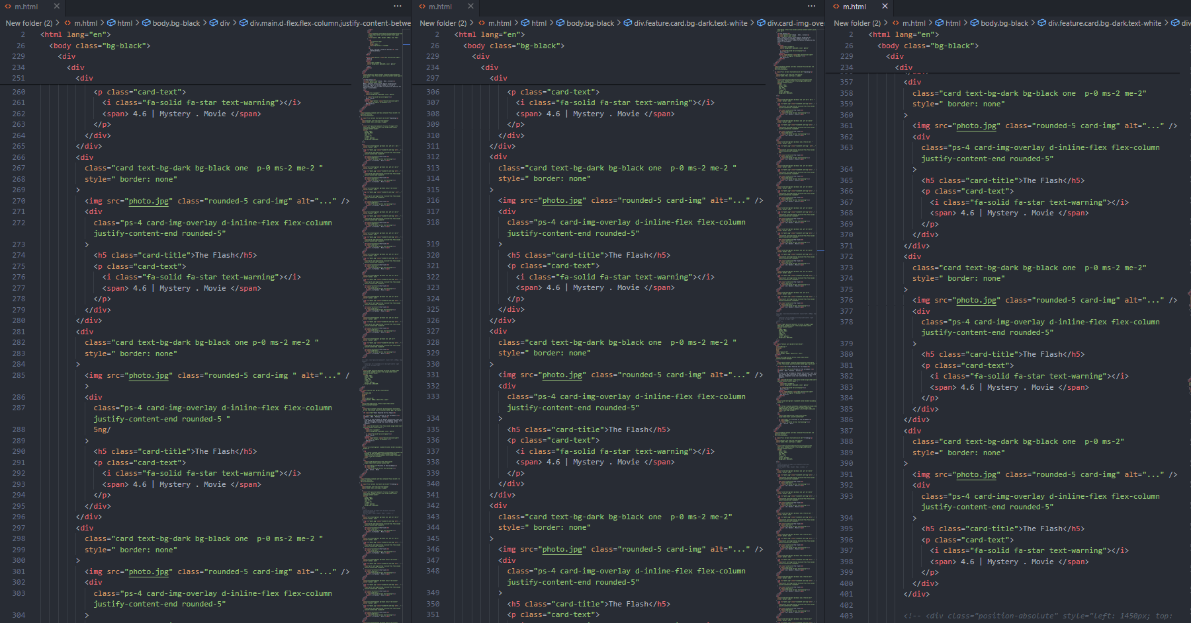

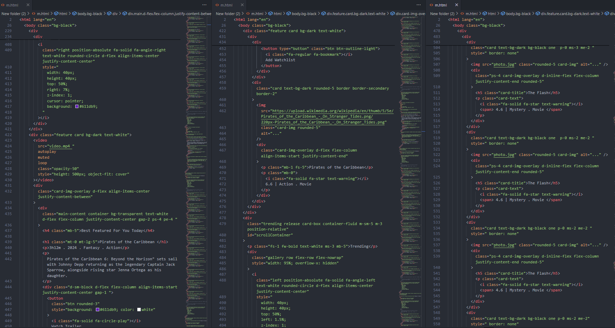

FEE-II,22CS0014

9

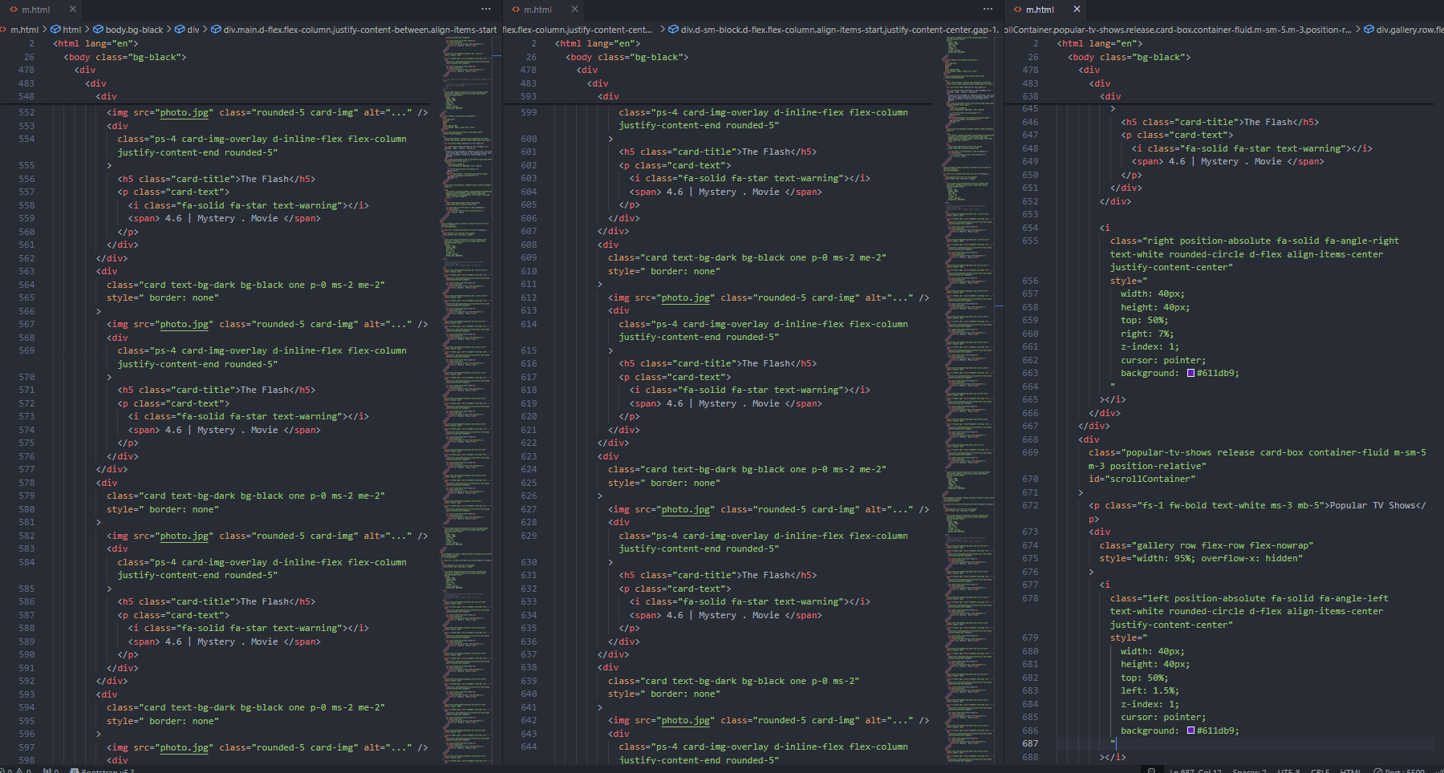

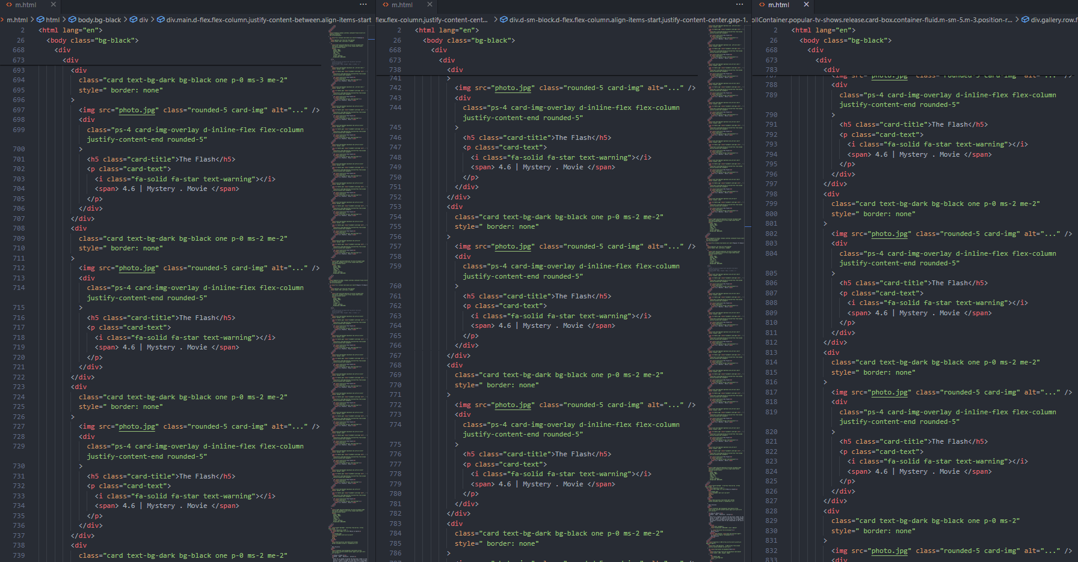

FEE-II, 22CS0014

10

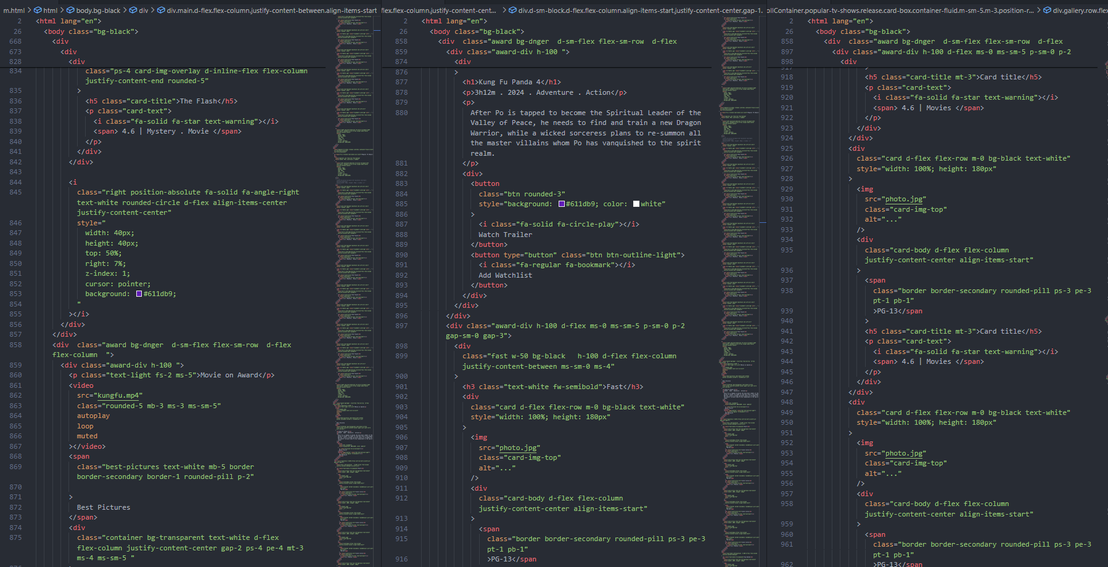

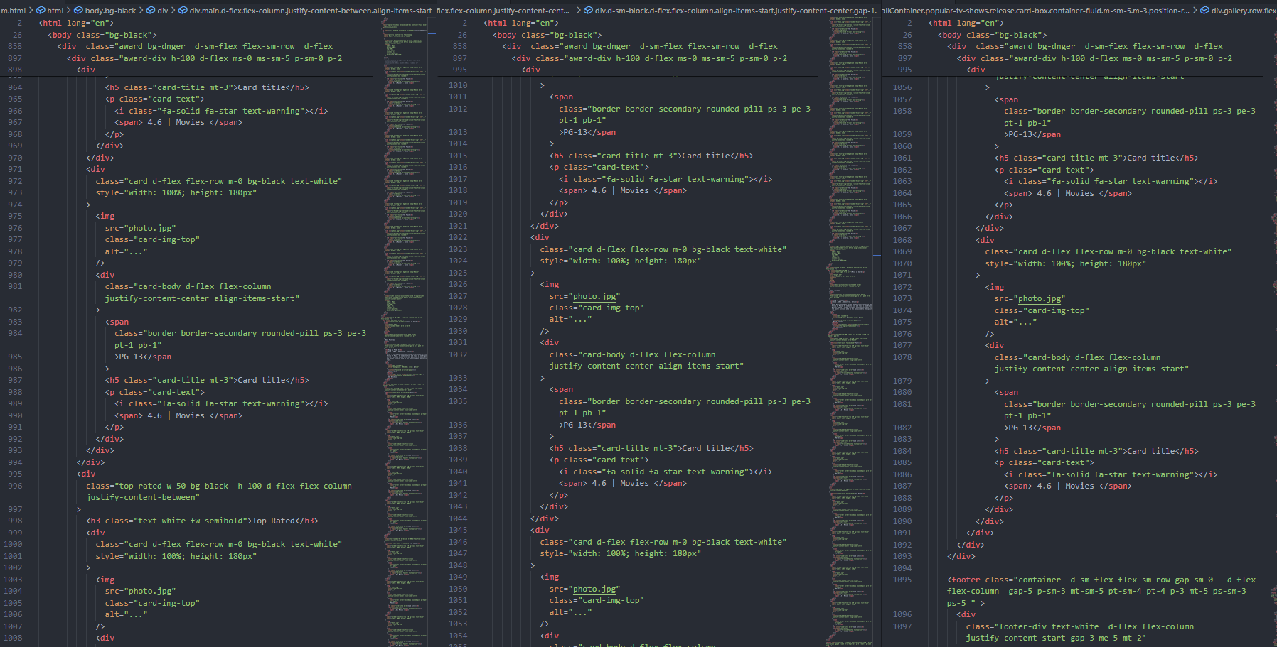

FEE-II,22CS0014

11

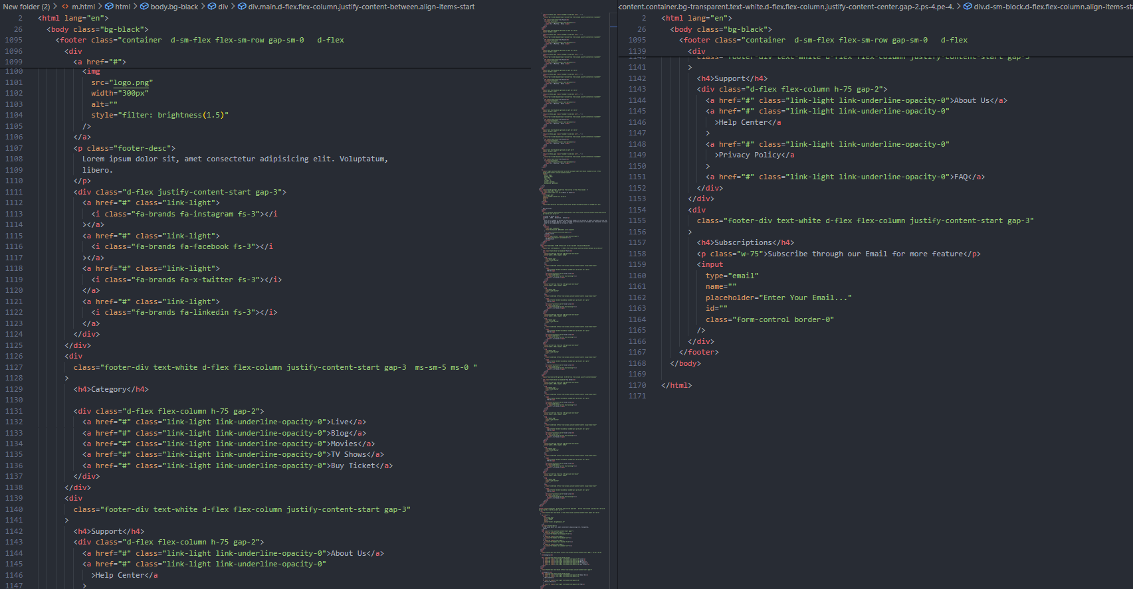

**CSS CODE-:**

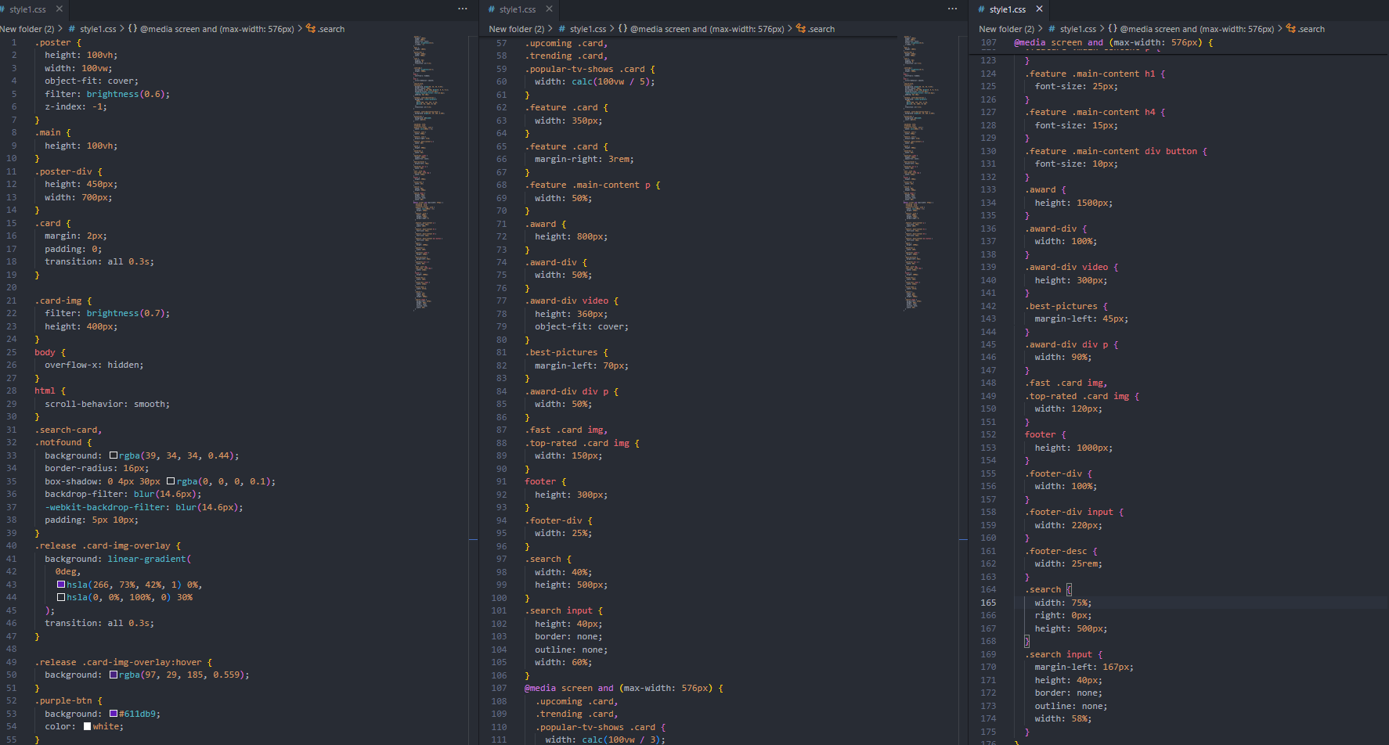

FEE-II,22CS0014

12

JS CODE-:

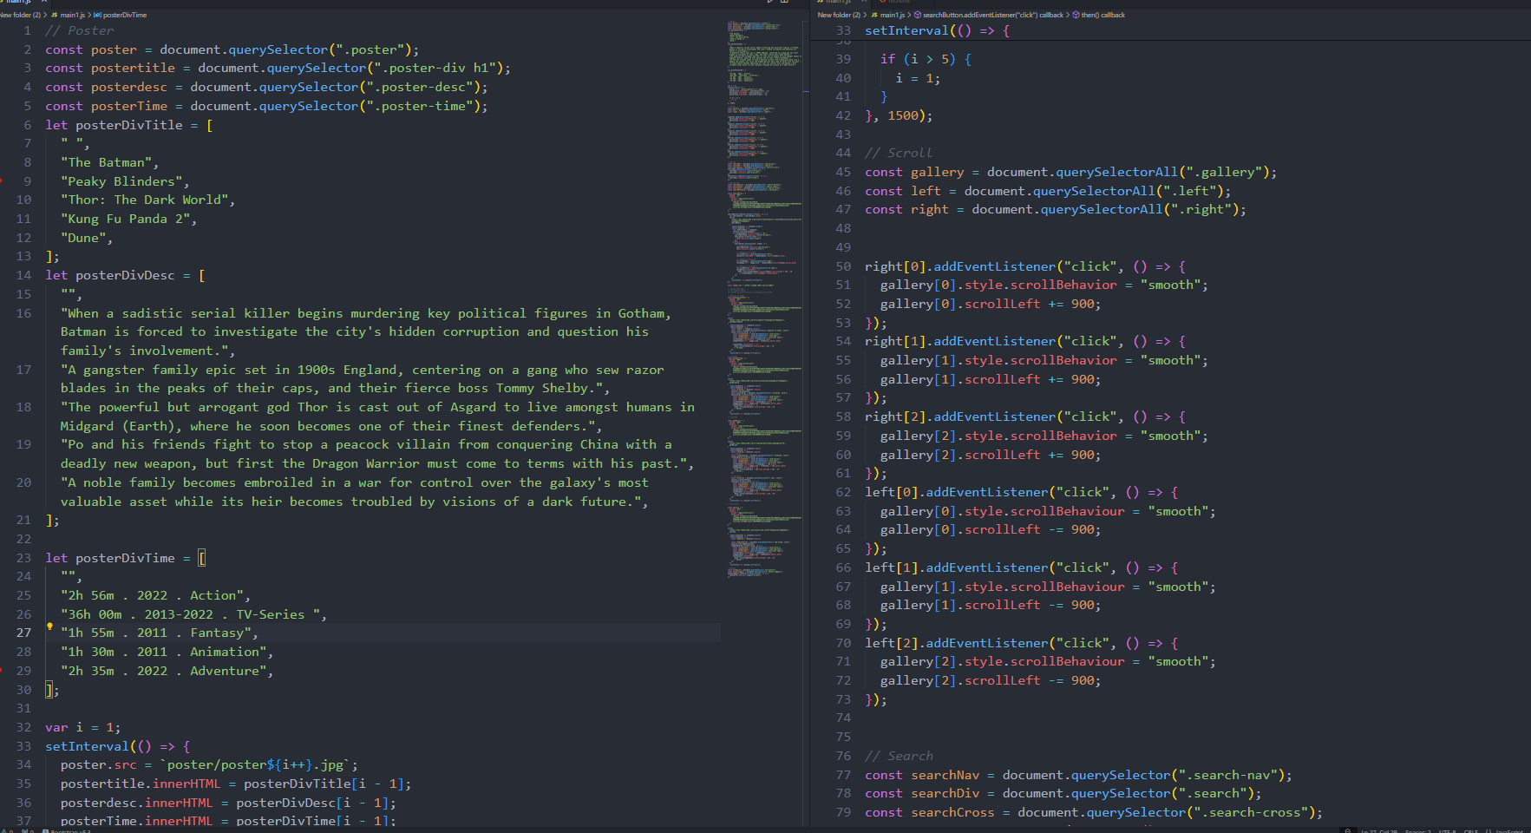

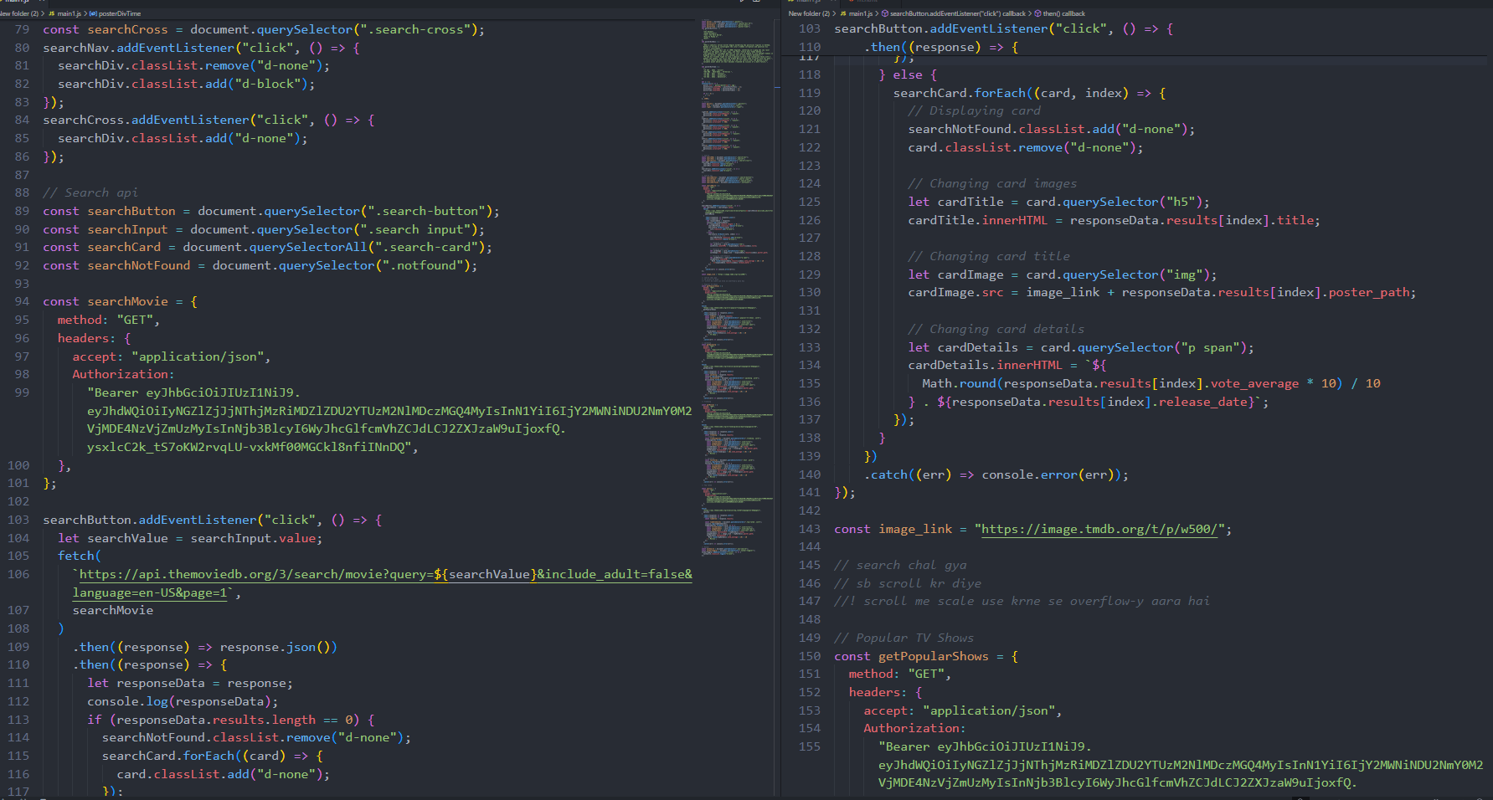

FEE-II,22CS0014

13

**JS CODE -**

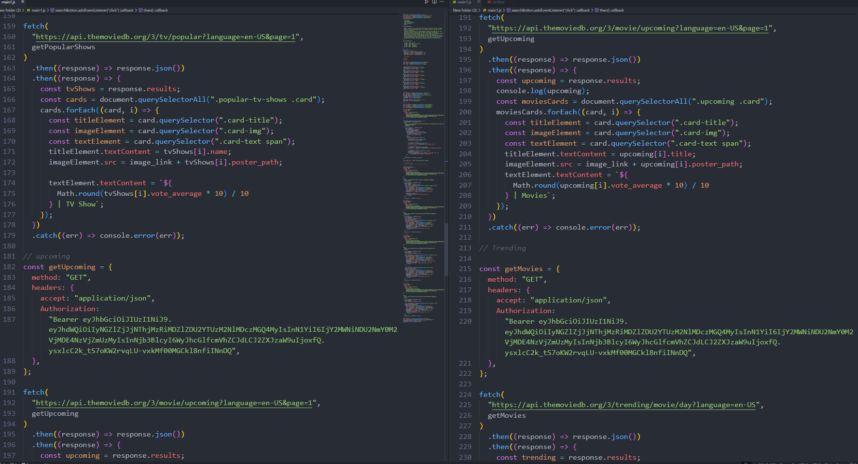

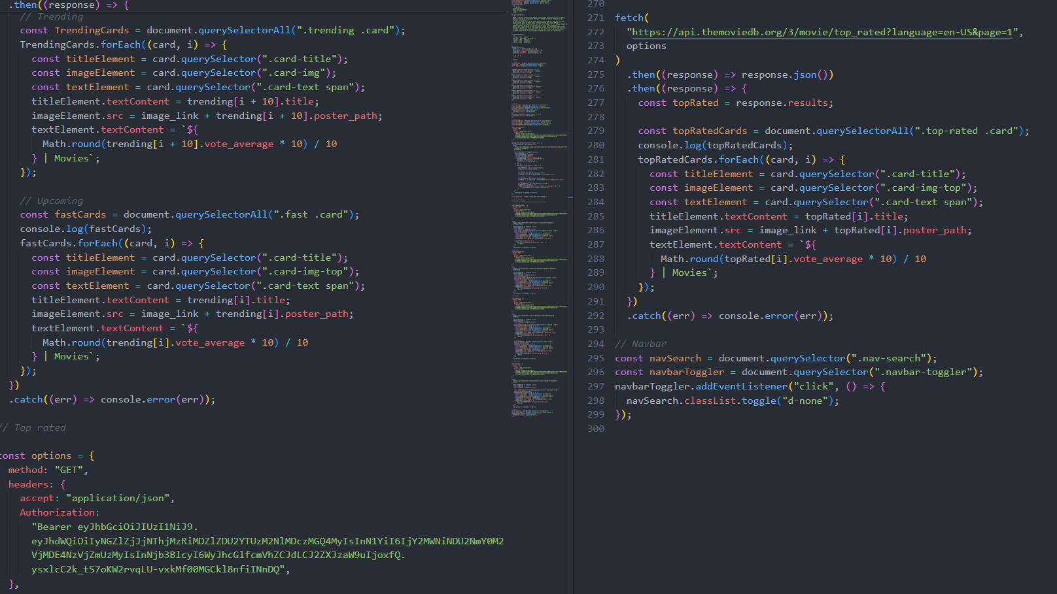

FEE-II,22CS0014

14

**DESKTOP VIEW-:**

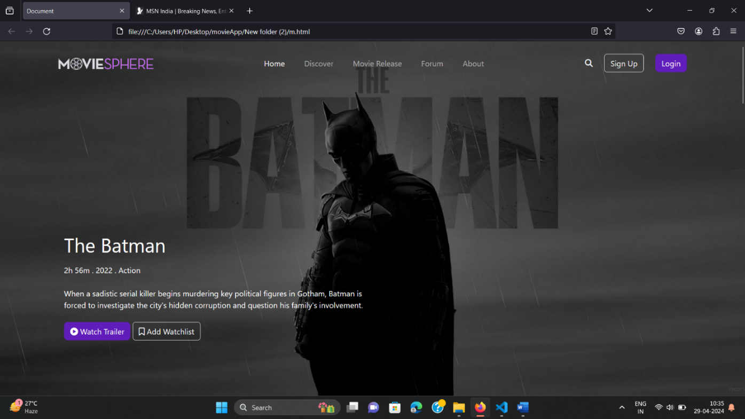

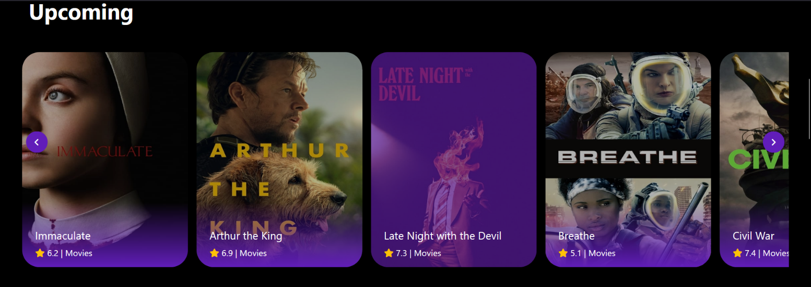

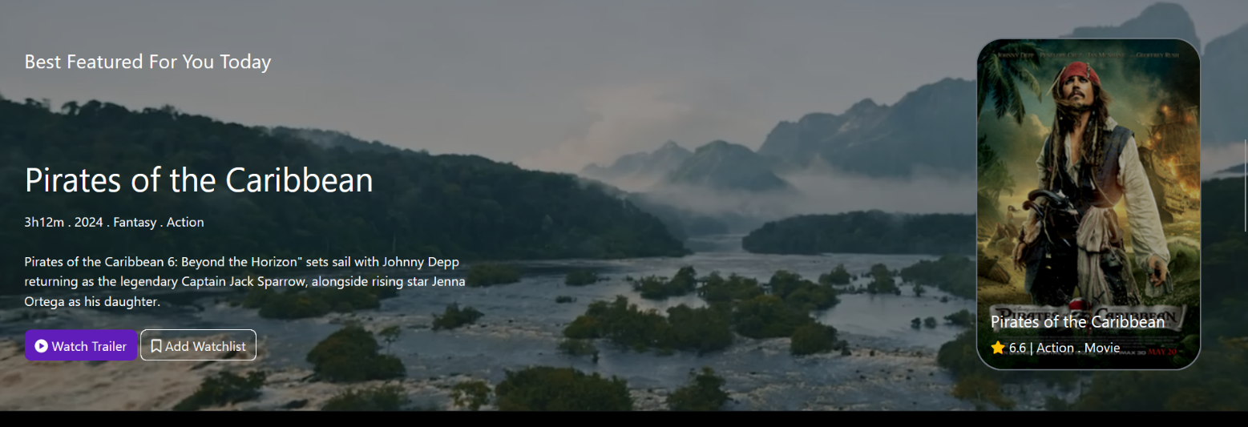

FEE-II,22CS0014

15

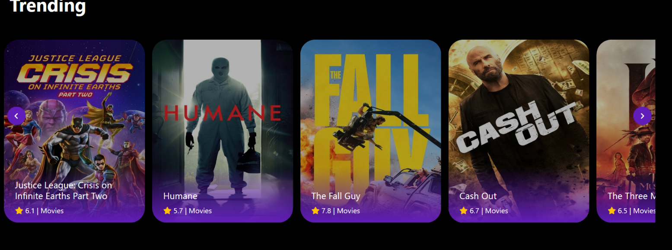

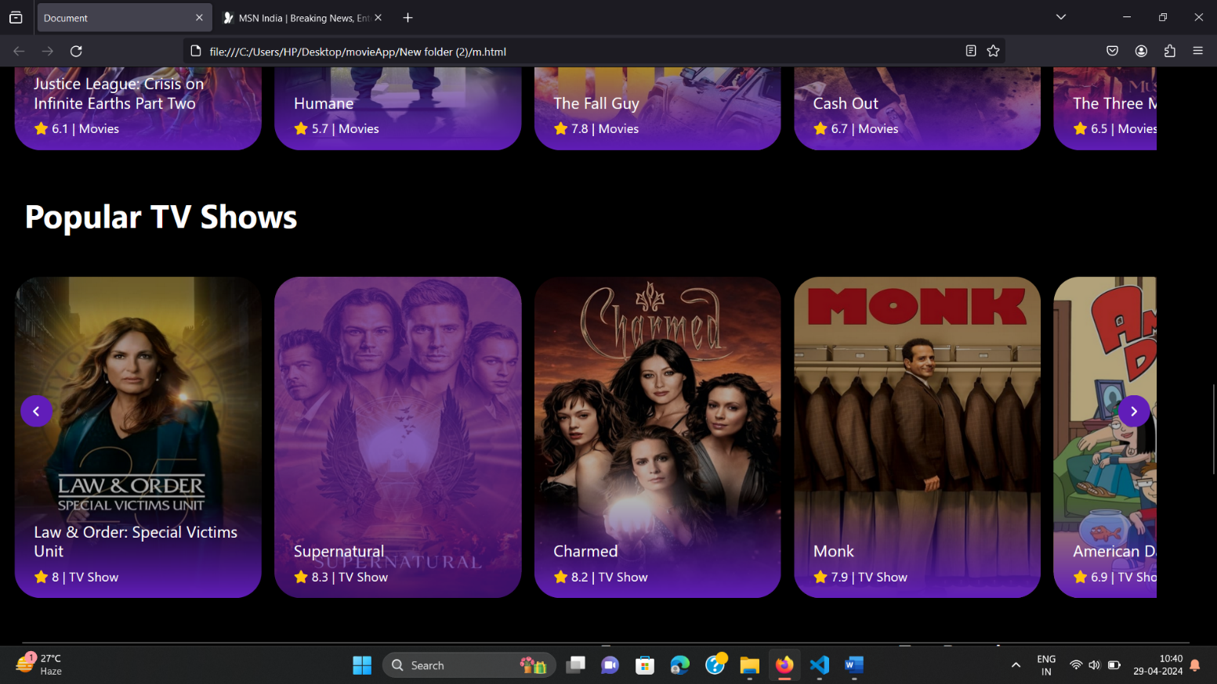

FEE-II, 22CS0014

16

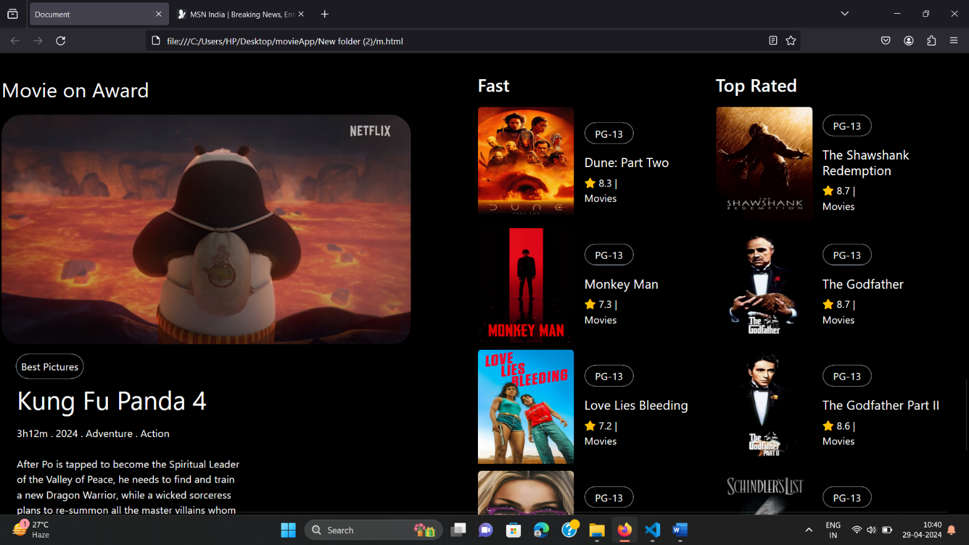

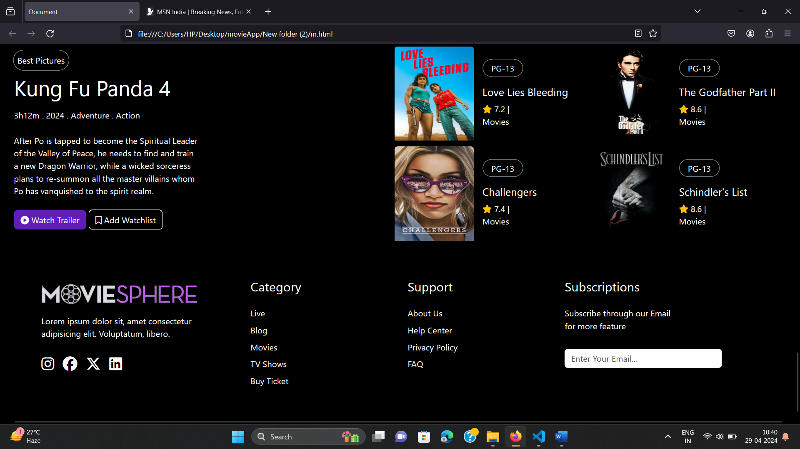

17

FEE-II, 22CS0014

**MOBILE VIEW-**

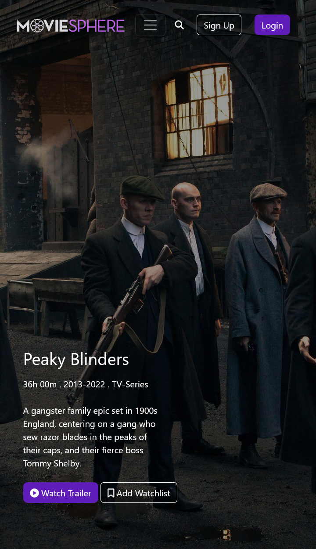

18

FEE-II, 22CS0014

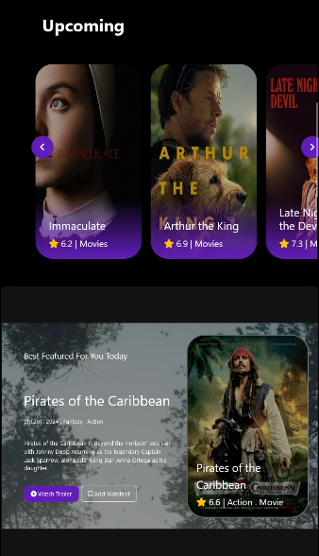

19

FEE-II, 22CS0014

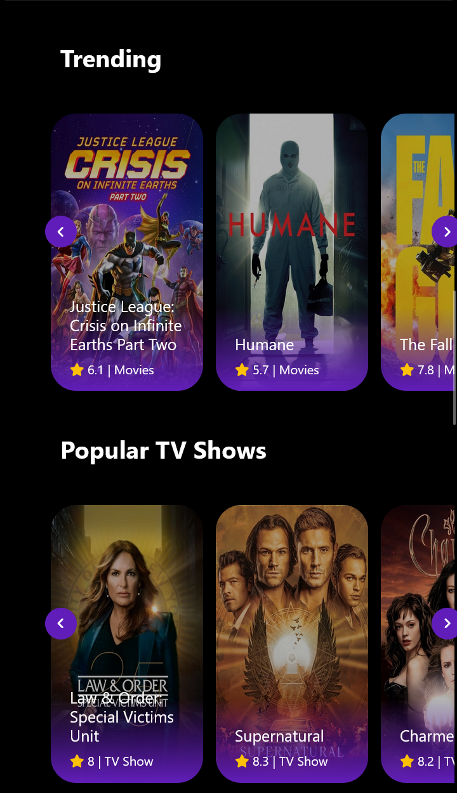

FEE-II, 22CS0014

20

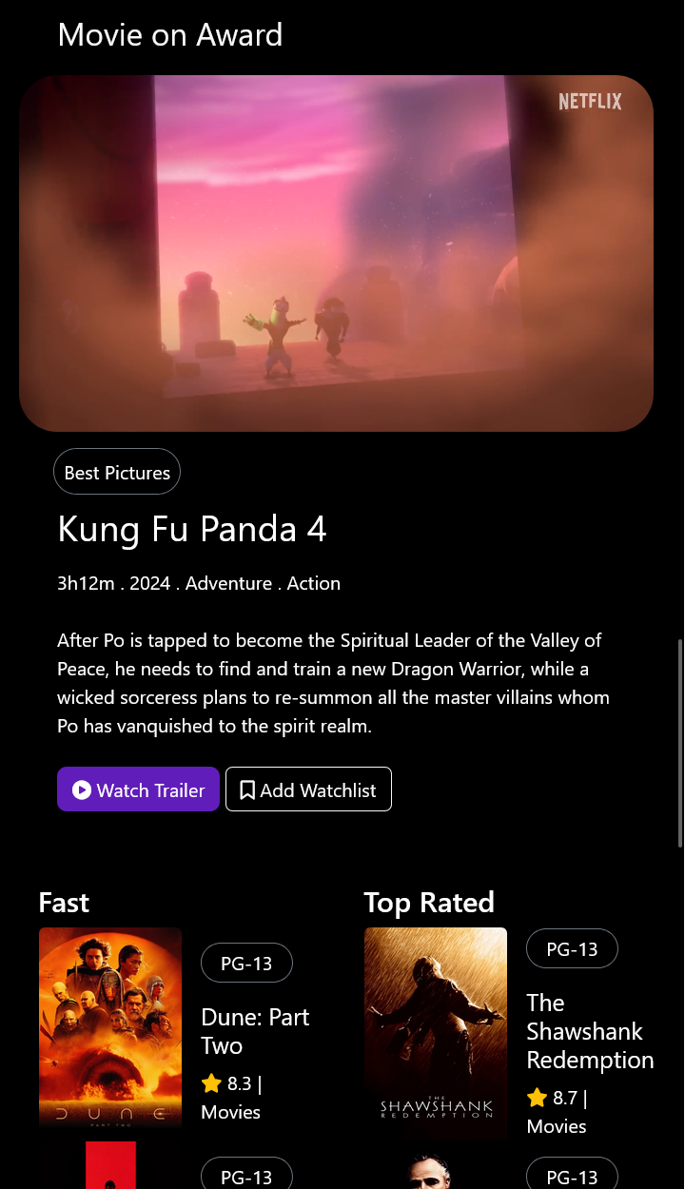

FEE-II, 22CS0014

21

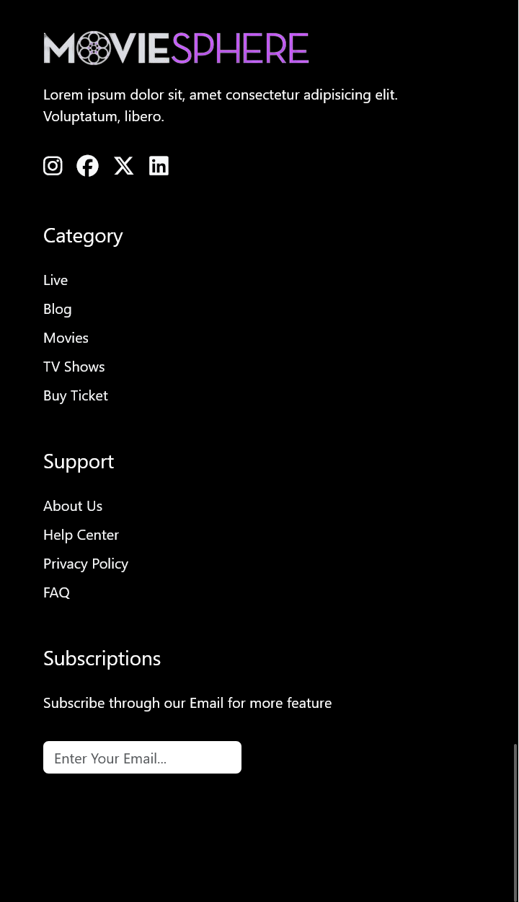

FEE-II, 22CS0014

22

**REFERENCES :-**

1. Figma: <https://www.figma.com>
2. Bootstrap docs: <https://getbootstrap.com/>
3. Font-awesome: <https://fontawesome.com/>

FEE-II, 22CS0014

23